Kubernetes Task 01

- Setup Minikube in your local machine.
Step 1: Install Docker Desktop (Windows)
Download and install:
Docker Desktop
https://docs.docker.com/desktop/install/windows-install/
After installation:
- Enable WSL2 backend
- Enable Virtualization in BIOS if required
Check installation: I have Already Installed Docker Desktop
docker --version
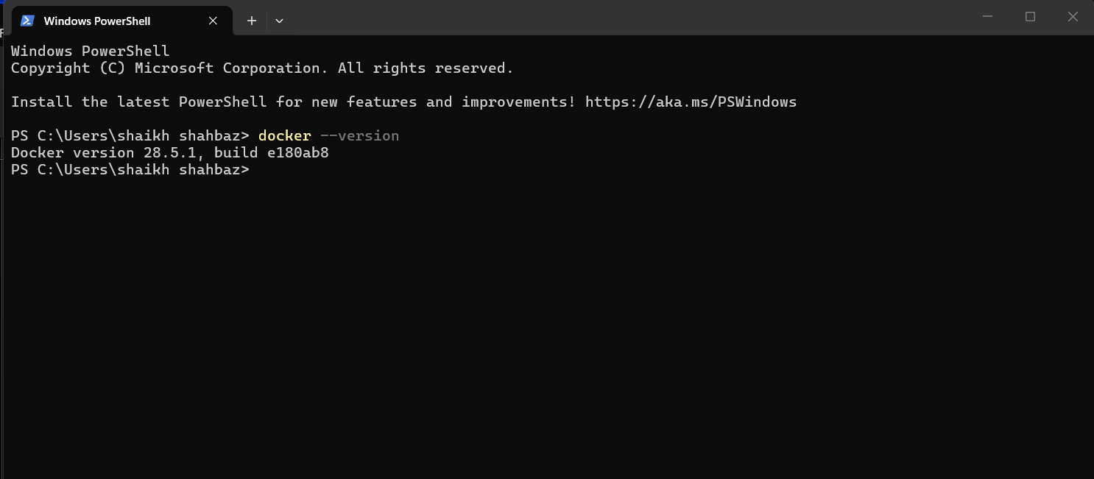
Step 2: Install VirtualBox (Optional if not using Docker driver)
Download:
Oracle VM VirtualBox
https://adamtheautomator.com/install-virtualbox-on-windows-10/
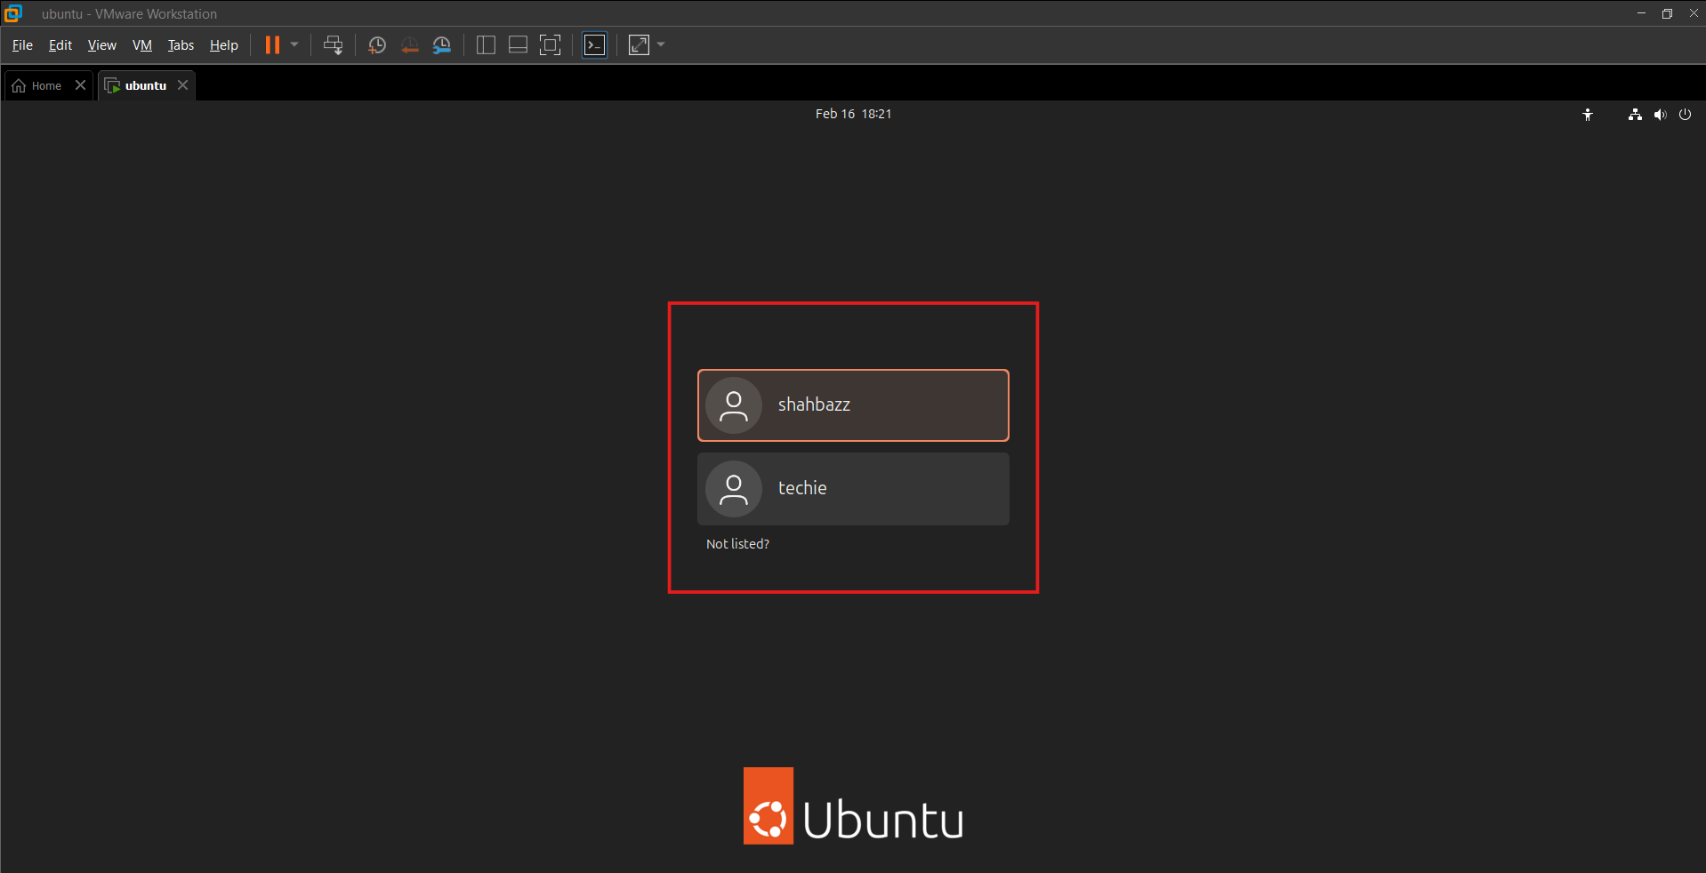

1️⃣ Setup Minikube in Local Machine (Windows)
Step 1: Verify Docker Installation
Using:
docker --version
Output:
Docker version 28.5.1
Docker is installed and working.
Using:
Docker Desktop
Minikube uses Docker as its driver.
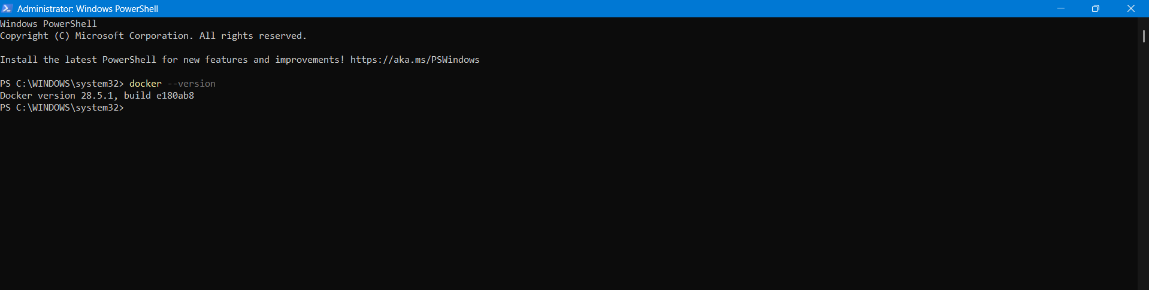

Step 2: Create Minikube Directory
New-Item -Path "C:\" -Name "minikube" -ItemType Directory -Force
Directory created:
C:\minikube
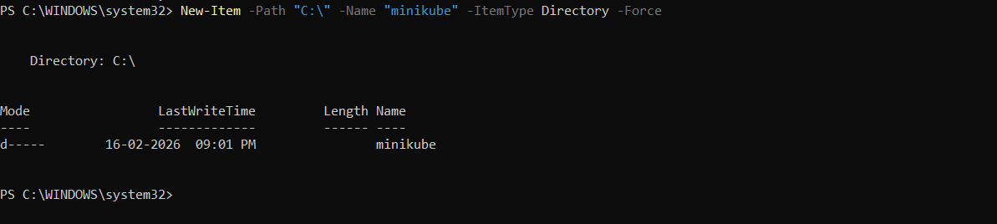
Step 3: Download Minikube Binary
$ProgressPreference = 'SilentlyContinue'
Invoke-WebRequest -OutFile "c:\minikube\minikube.exe" `
-Uri "https://github.com/kubernetes/minikube/releases/latest/download/minikube-windows-amd64.exe" `
-UseBasicParsing
Tool used:
Minikube
Binary location:
C:\minikube\minikube.exe
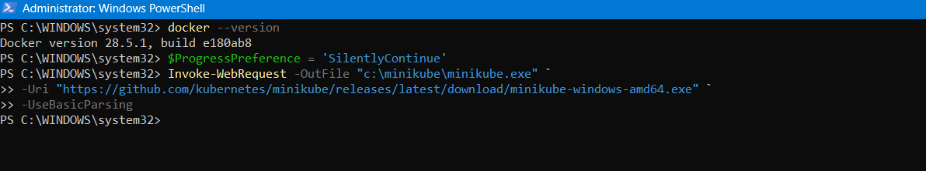
🔹 Step 4: Add Minikube to System PATH
$oldPath = [Environment]::GetEnvironmentVariable("Path", [EnvironmentVariableTarget]::Machine)

if ($oldPath.Split(";") -notcontains "C:\minikube") {
[Environment]::SetEnvironmentVariable("Path", "${oldPath};C:\minikube", [EnvironmentVariableTarget]::Machine)
}
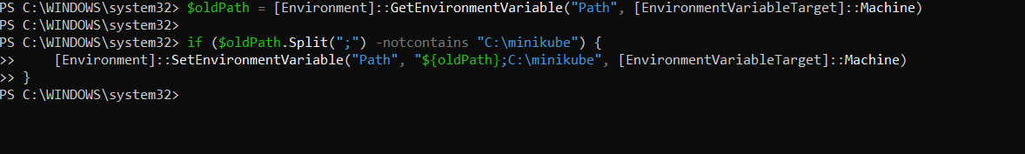
Restart PowerShell.
Now we have to define minikube Path in Environment variables in local system (Your laptop)
Go to windows search for environment variables select path edit
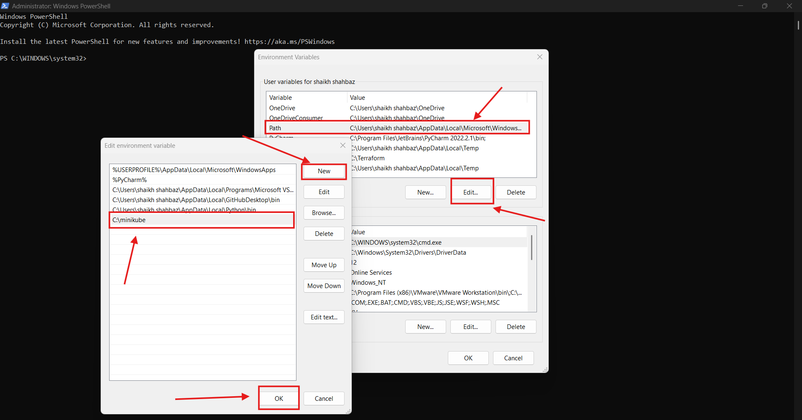
🔹 Step 5: Verify Installation
minikube version
Output:
minikube version: v1.38.0
Minikube installed successfully
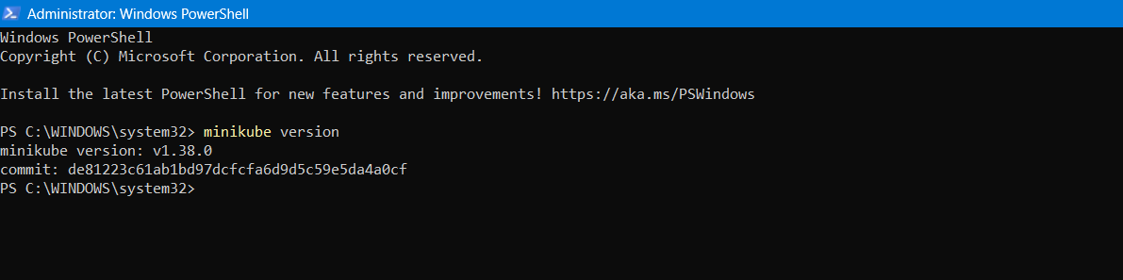
Step 6: Start Minikube Cluster
minikube start
Minikube:
- Automatically selected Docker driver
- Using container runtime: containerd
- Pulled Kubernetes base image
- Created control-plane node
- Configured CNI
- Enabled addons:
  - storage-provisioner
  - default-storageclass
Cluster started successfully ✅
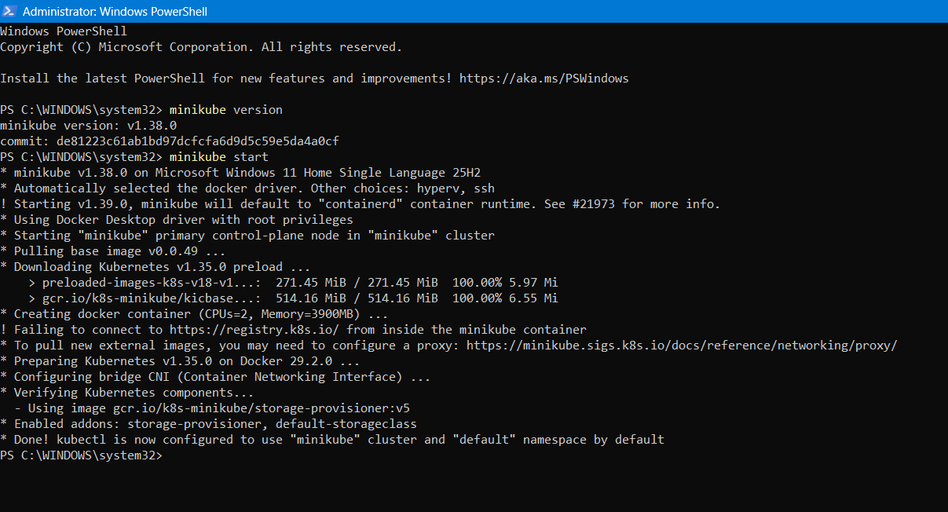
🔹 Step 7: Verify Cluster
minikube ip
Output:
192.168.49.2
Minikube cluster is running properly.
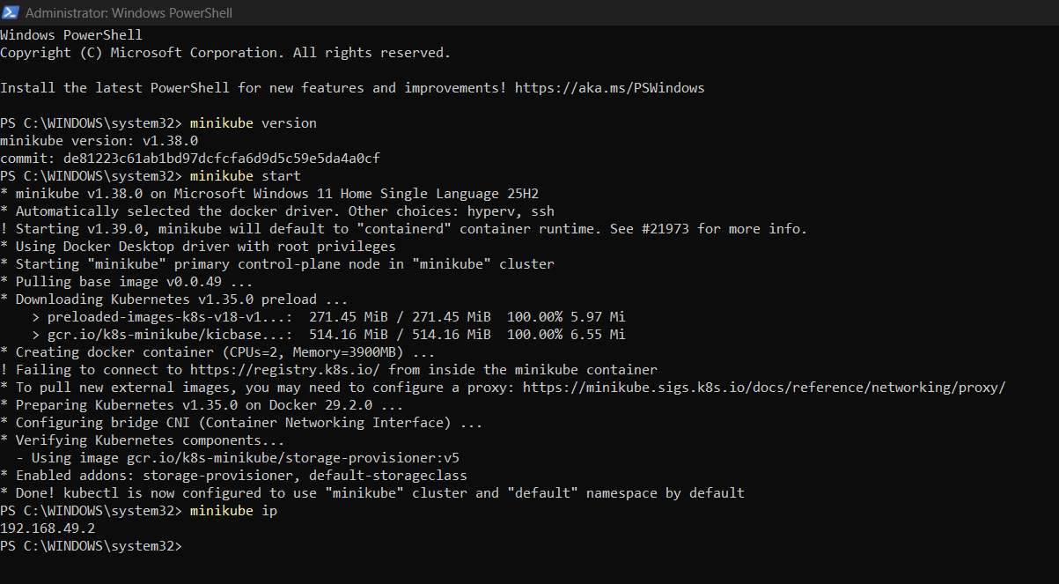

- Setup k8s master and two worker nodes on ubuntu.
Infrastructure:
- 3 Ubuntu 24.04 LTS EC2 instances
- Same VPC
- Same Security Group
- 20GB storage
- t2/t3 instance type : t3.large
- 20 Gb storage
Using:
Kubernetes
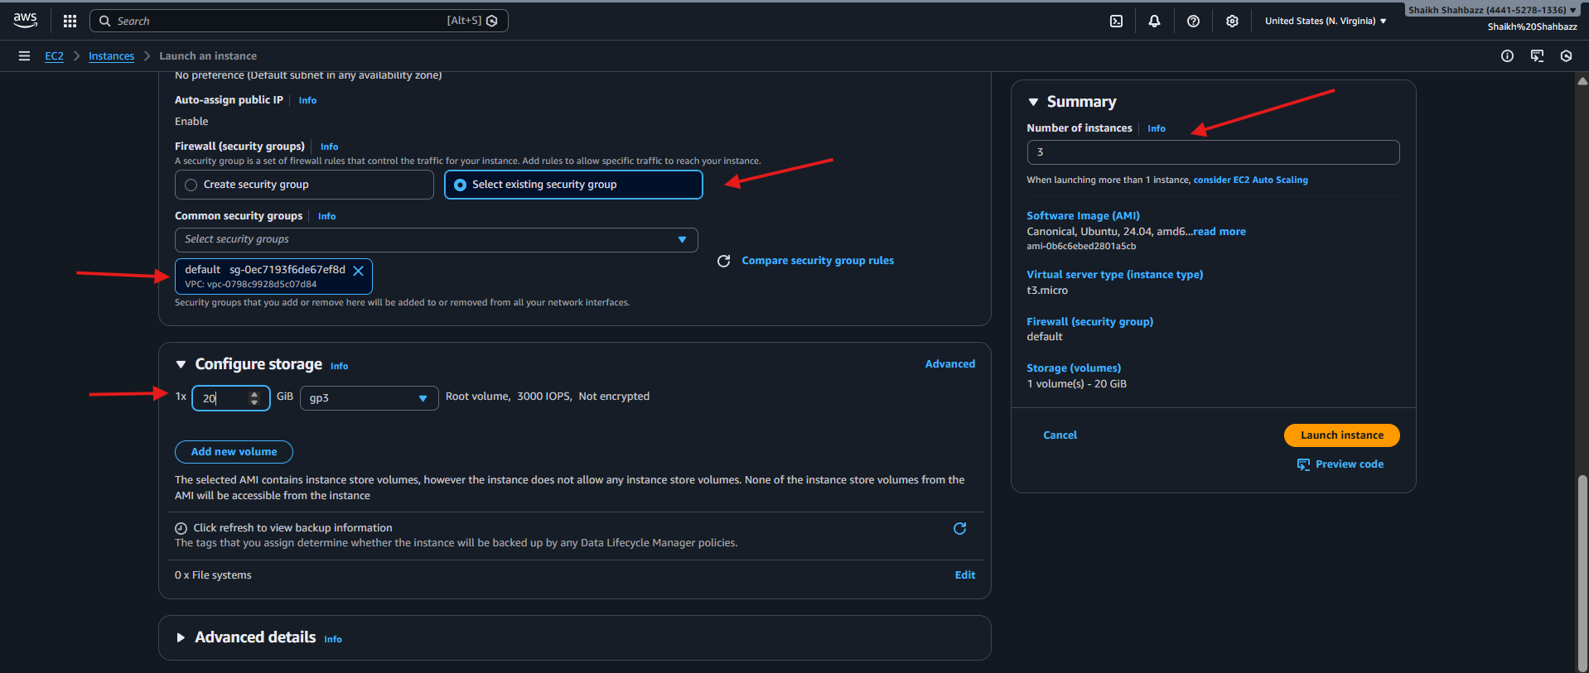
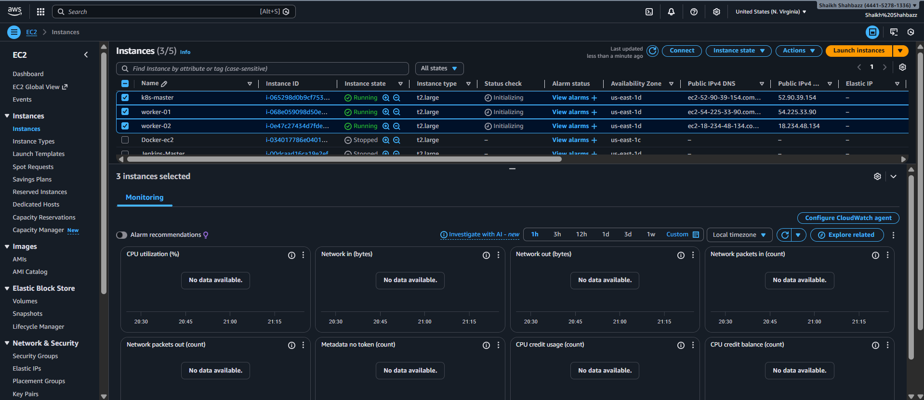
Step 1: Configure Hostnames (All Nodes)
On Master:
sudo su –
swapoff -a
free -h
sudo hostnamectl set-hostname k8s-master
exit
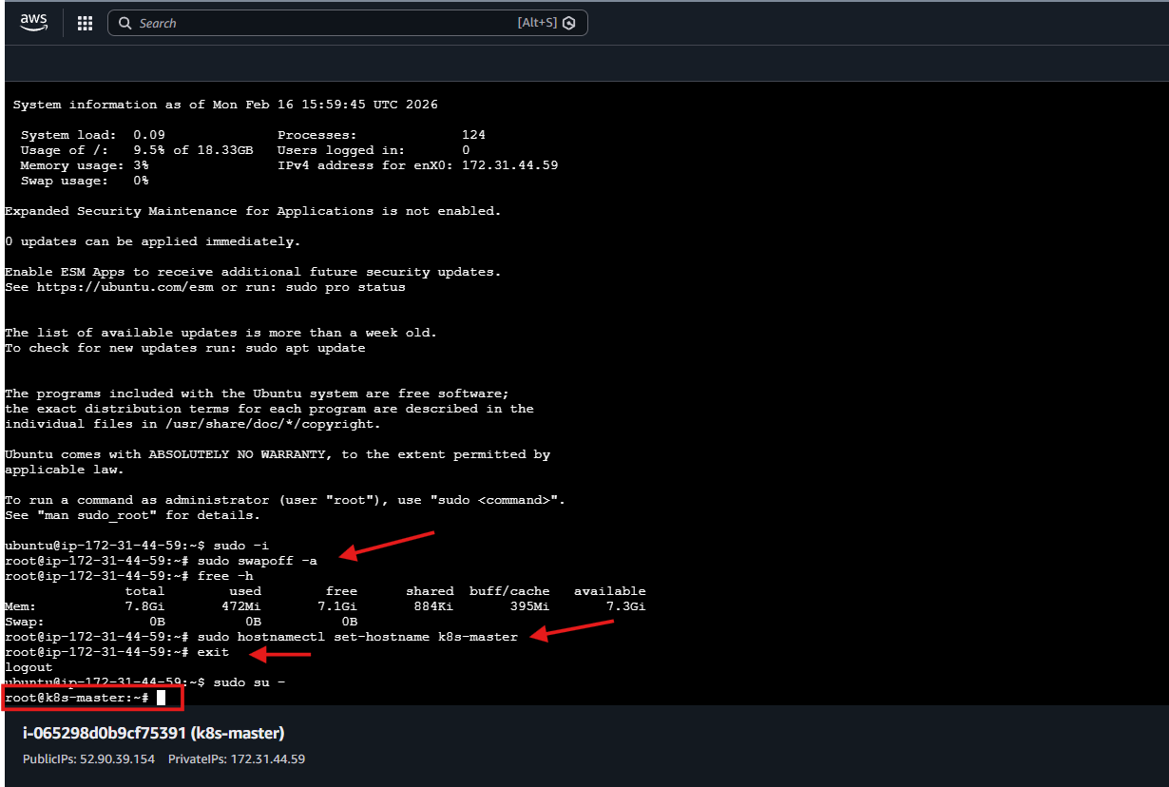
On Worker-01:
sudo su –
swapoff -a
free -h
sudo hostnamectl set-hostname worker01
exit
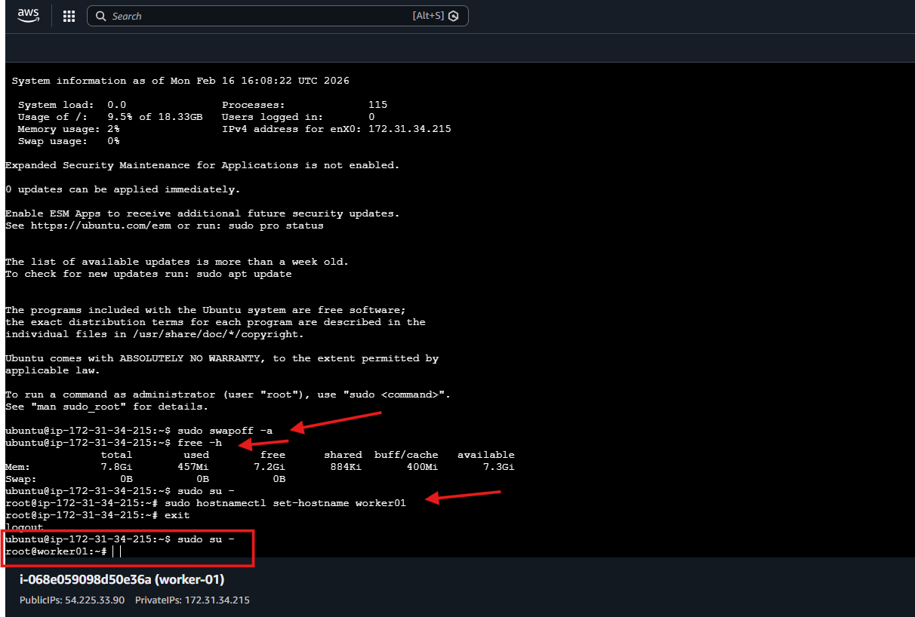
On Worker-02:
sudo su –
swapoff -a
free -h
sudo hostnamectl set-hostname worker02
exit
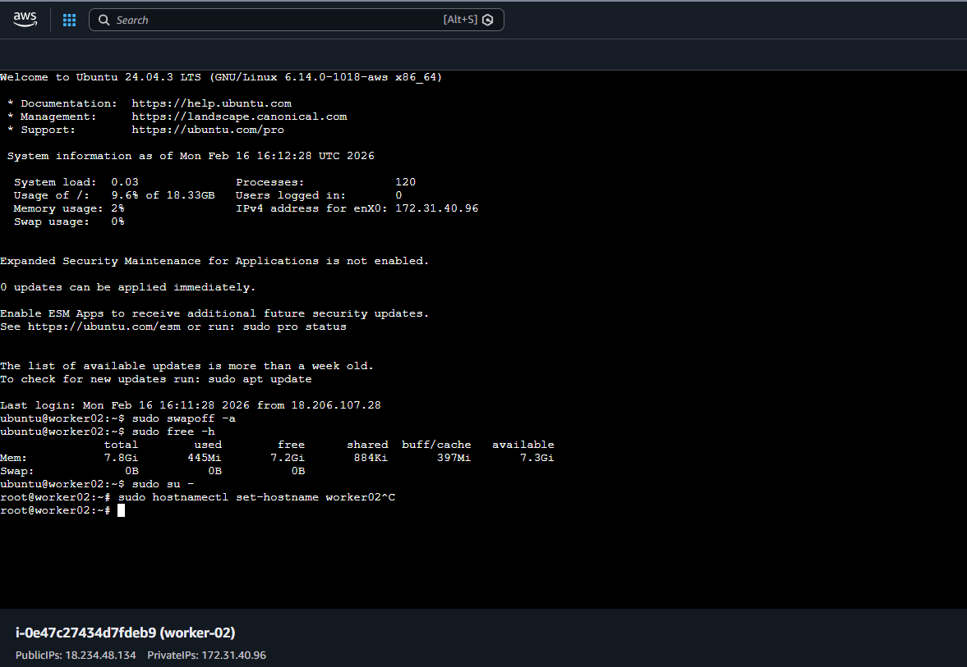

Step 2: Update /etc/hosts (All Nodes)
sudo vi /etc/hosts
Added private ips:
172.31.44.59 k8s-master
172.31.34.215 worker01
172.31.40.96 worker02
On master:
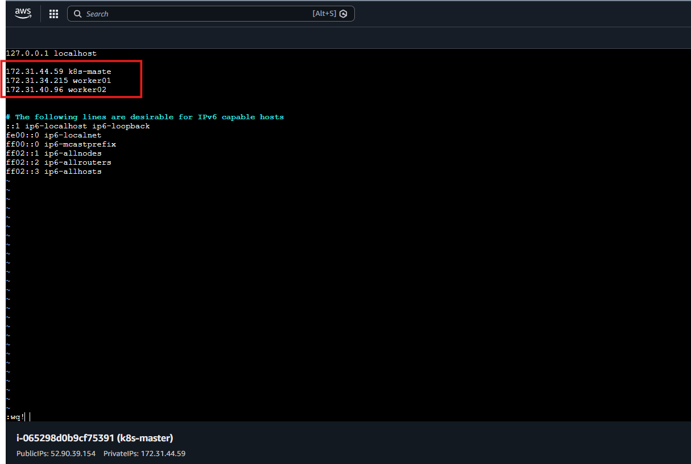

ping worker01
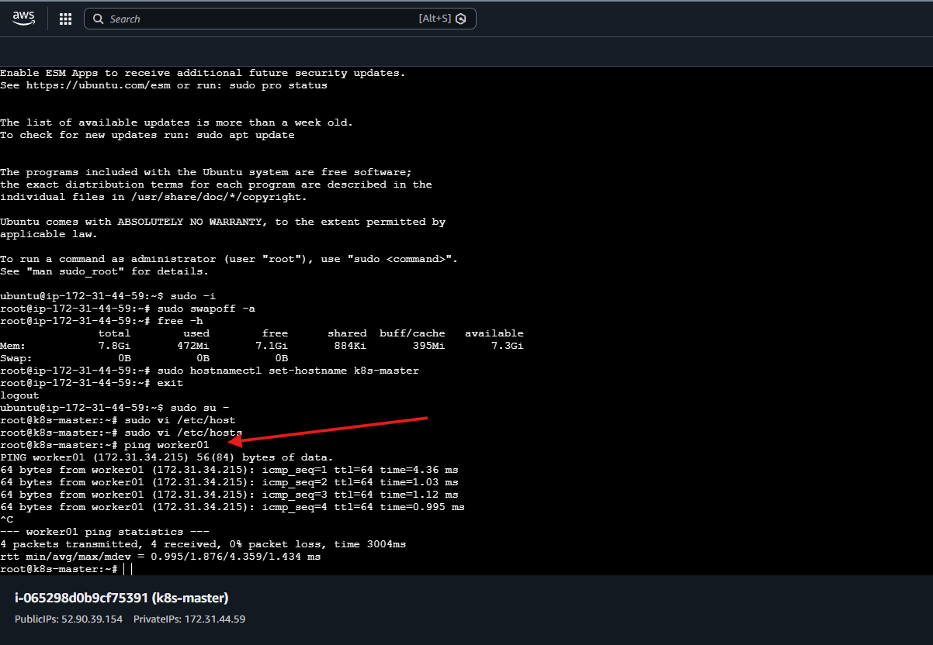

On worker01:
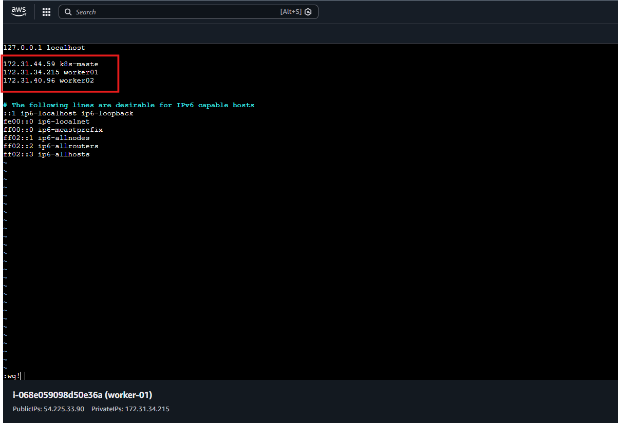

ping k8s-master
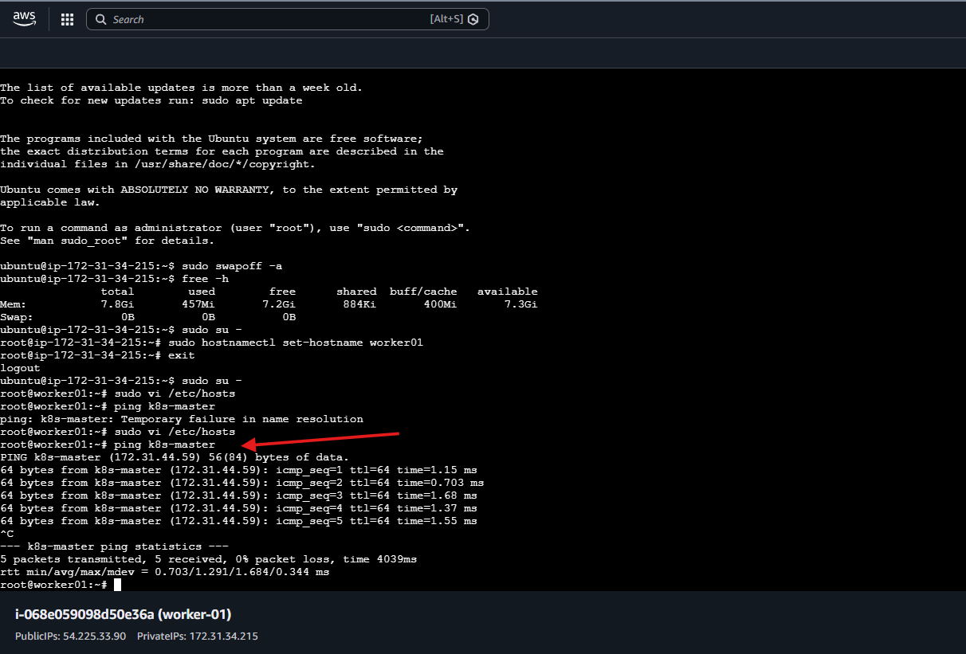
On worker02:
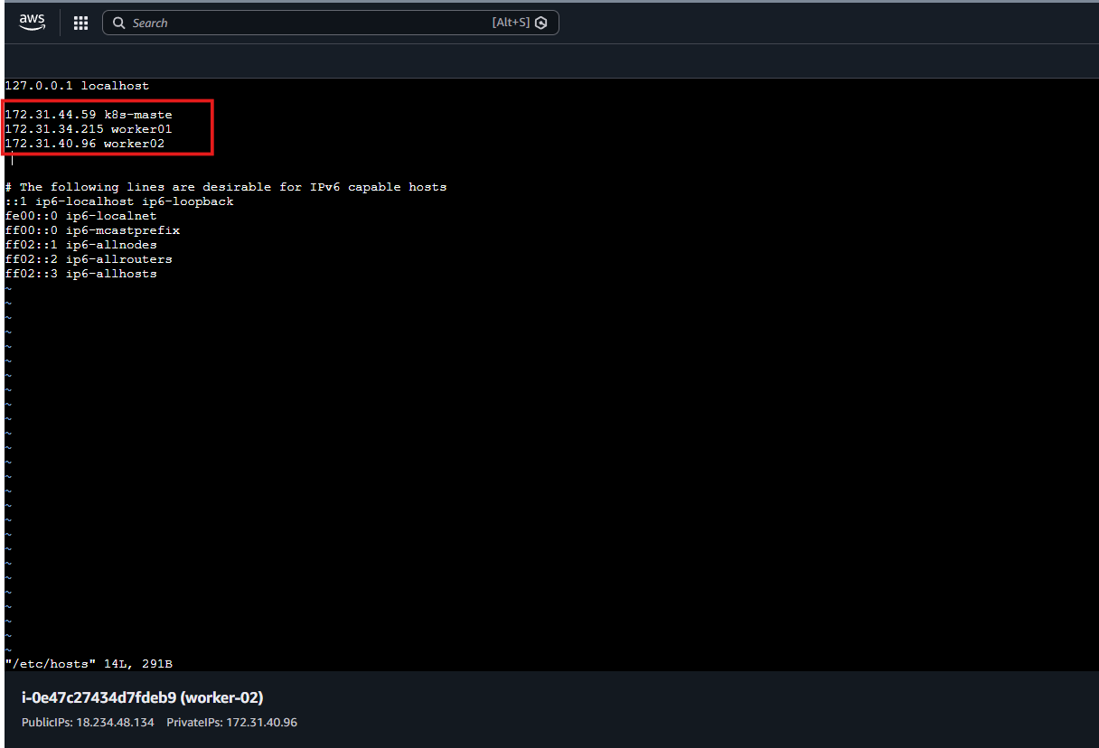

ping k8s-master
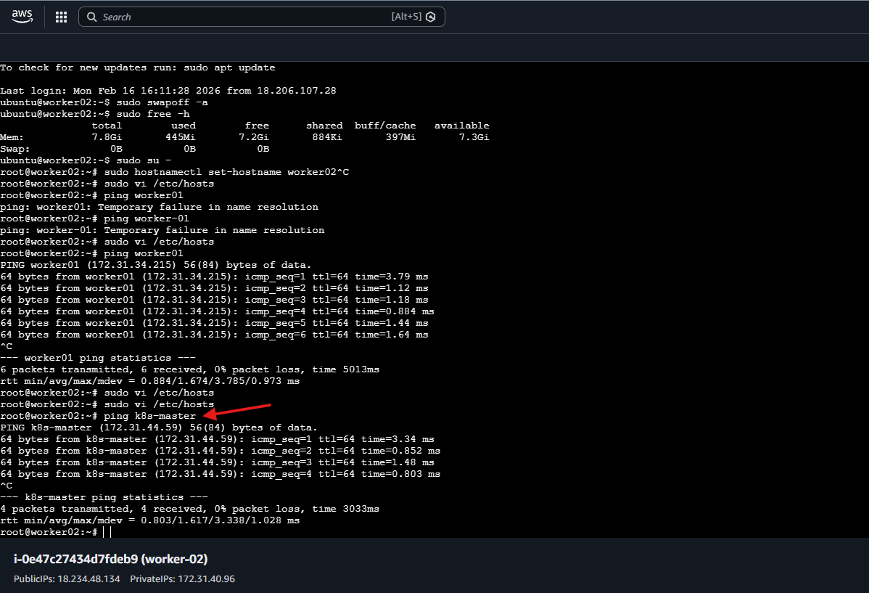

Step 3: Enable Required Kernel Modules
cat <<EOF | sudo tee /etc/modules-load.d/k8s.conf
overlay
br_netfilter
EOF
sudo modprobe overlay
sudo modprobe br_netfilter
# sysctl params required by setup, params persist across reboots
cat <<EOF | sudo tee /etc/sysctl.d/k8s.conf
net.bridge.bridge-nf-call-iptables = 1
net.bridge.bridge-nf-call-ip6tables = 1
net.ipv4.ip_forward = 1
EOF
# Apply sysctl params without reboot
sudo sysctl –system
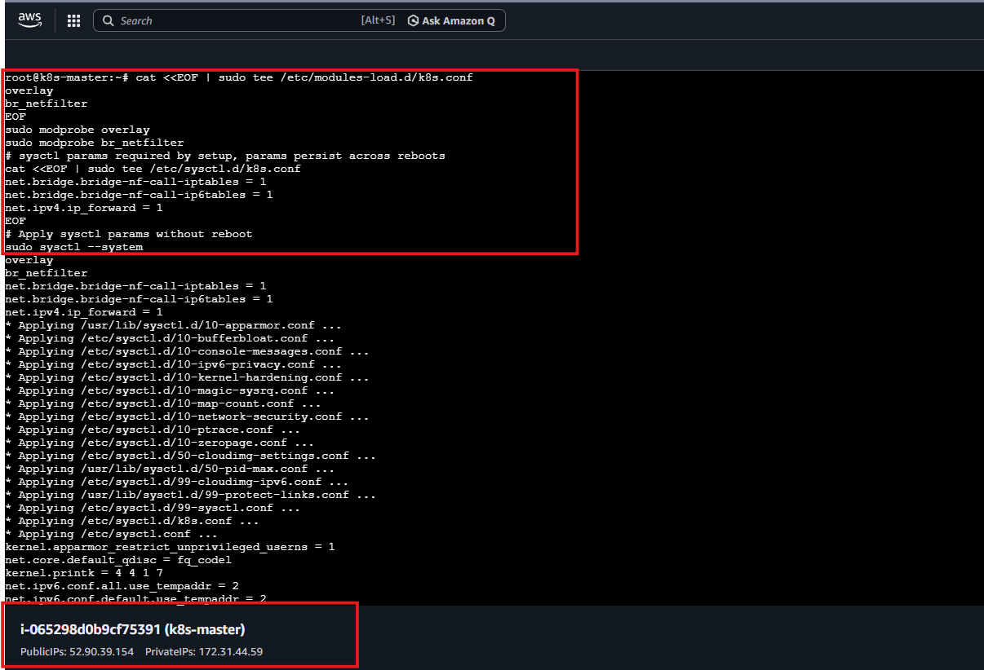

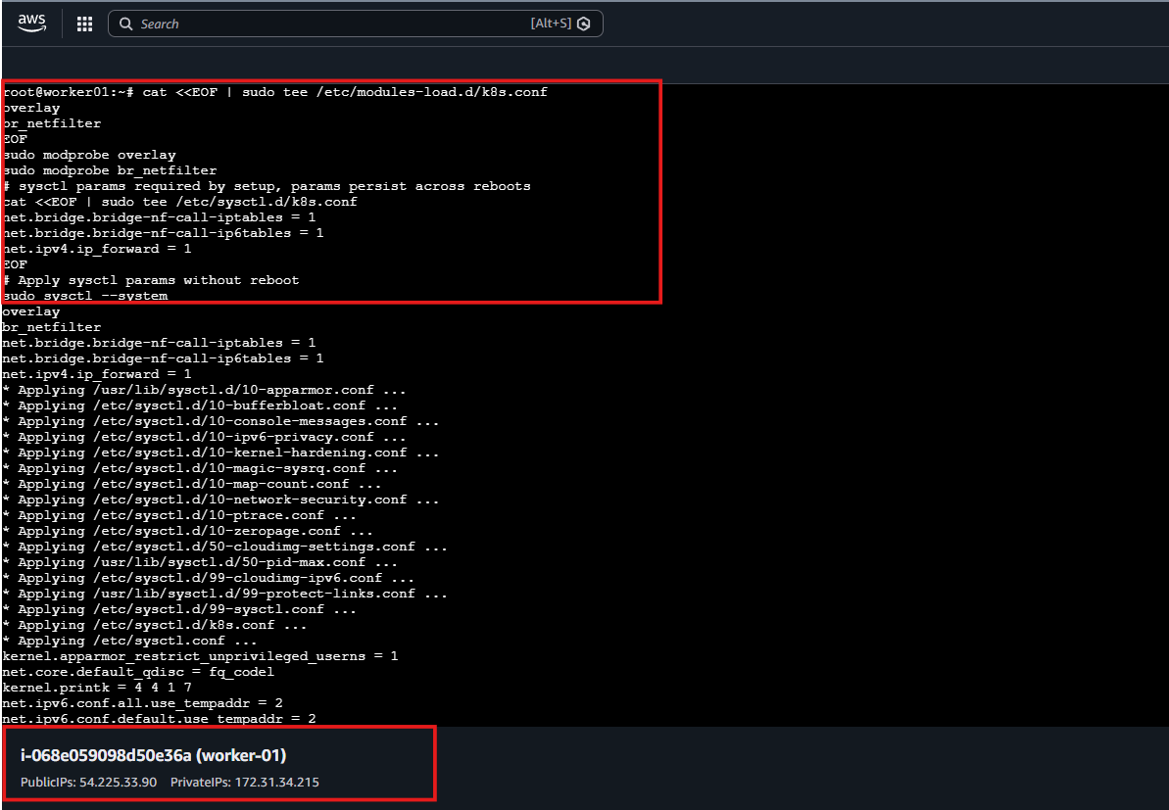

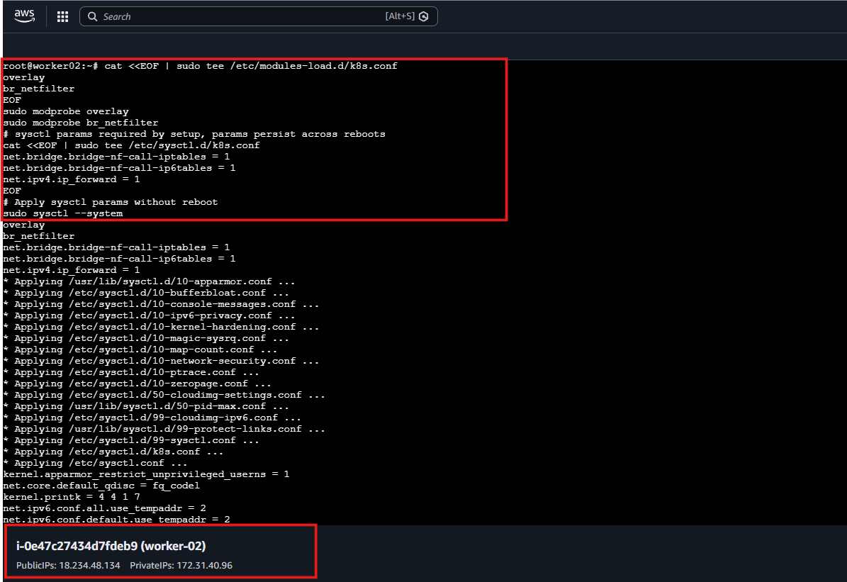

🔹 Step 5: Configure Sysctl Parameters
sudo apt update
sudo apt install -y apt-transport-https ca-certificates curl gpg

sudo mkdir -p /etc/apt/keyrings

curl -fsSL https://pkgs.k8s.io/core:/stable:/v1.29/deb/Release.key | \
sudo gpg --dearmor -o /etc/apt/keyrings/kubernetes-apt-keyring.gpg

echo 'deb [signed-by=/etc/apt/keyrings/kubernetes-apt-keyring.gpg] https://pkgs.k8s.io/core:/stable:/v1.29/deb/ /' | \
sudo tee /etc/apt/sources.list.d/kubernetes.list

sudo apt update
sudo apt install -y kubelet kubeadm kubectl
sudo apt-mark hold kubelet kubeadm kubectl
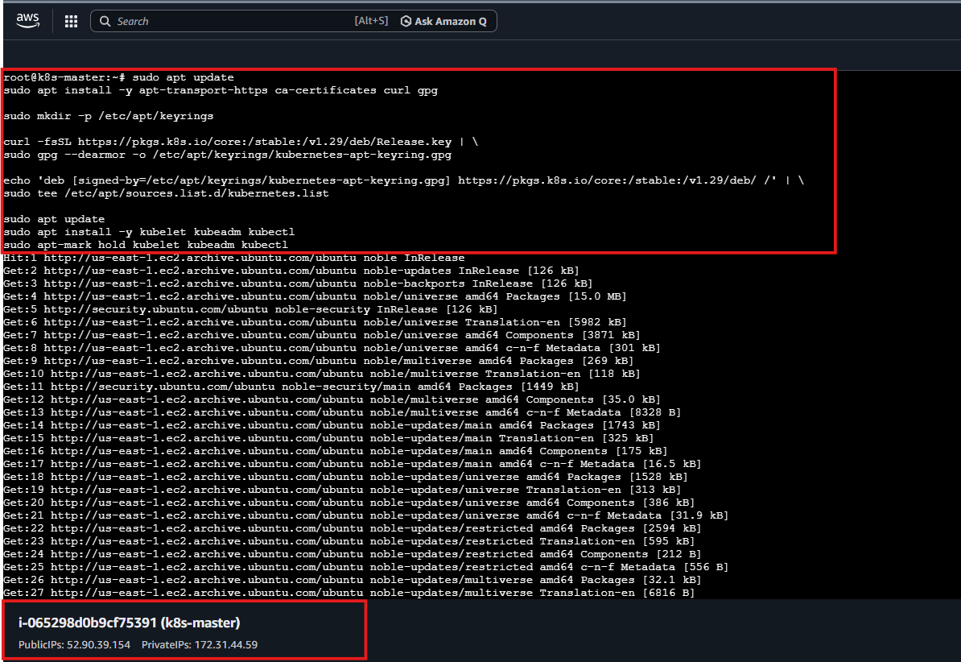

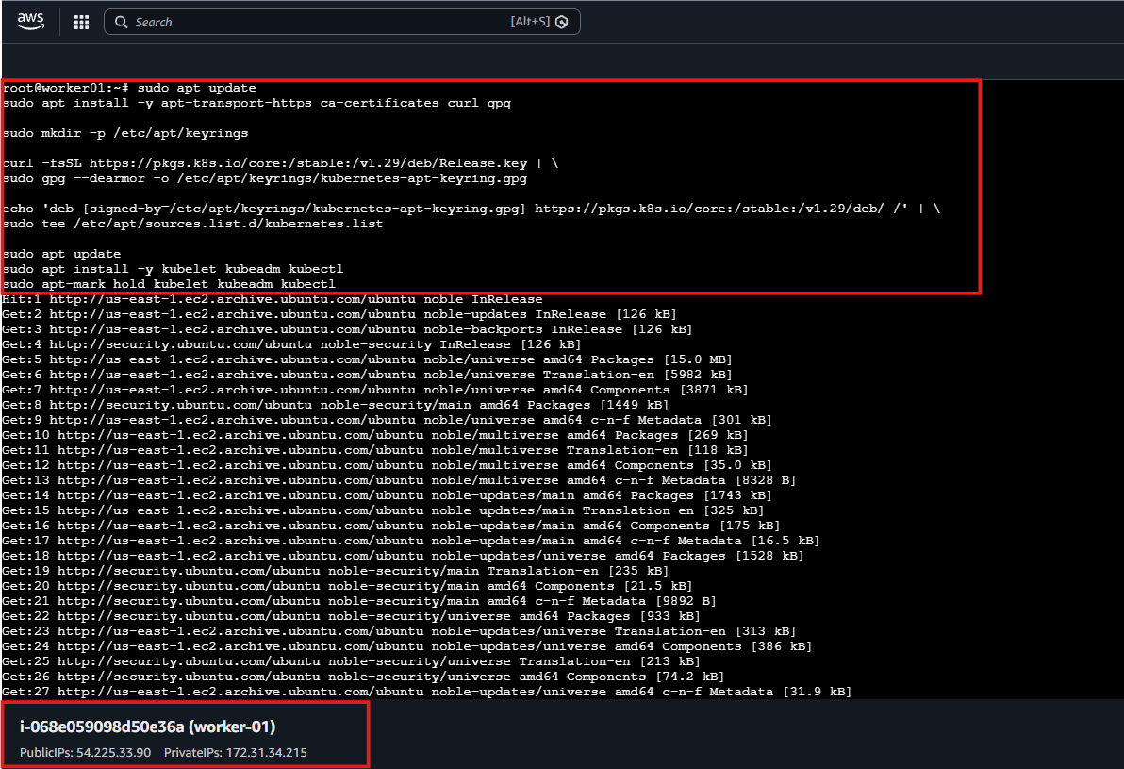

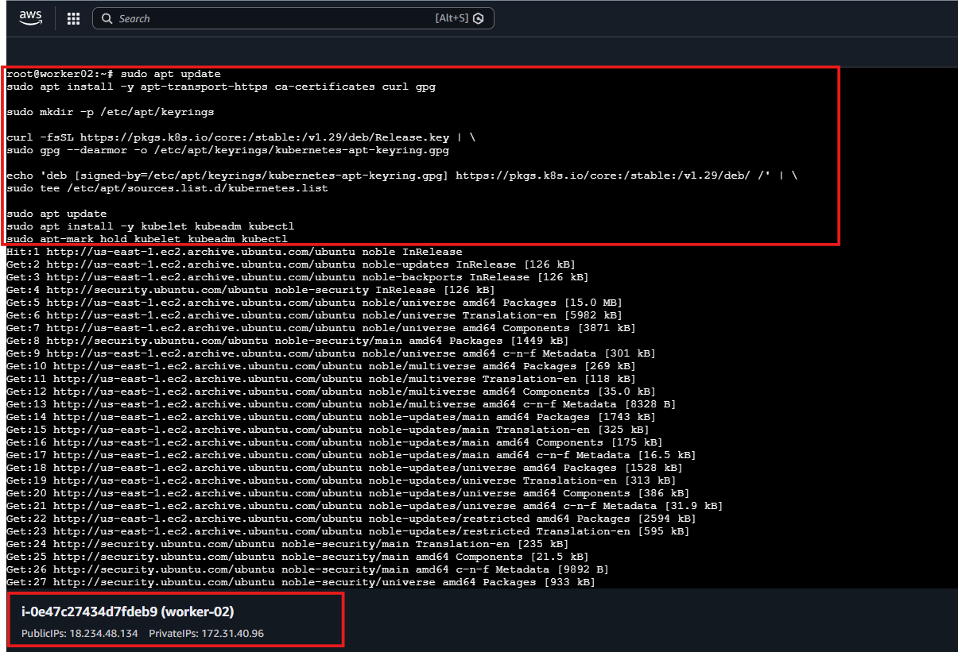

Step 6: Install Kubernetes Components
sudo apt install -y containerd

sudo mkdir -p /etc/containerd

sudo containerd config default | sudo tee /etc/containerd/config.toml

sudo sed -i 's/SystemdCgroup = false/SystemdCgroup = true/' /etc/containerd/config.toml

sudo systemctl restart containerd

sudo systemctl enable containerd
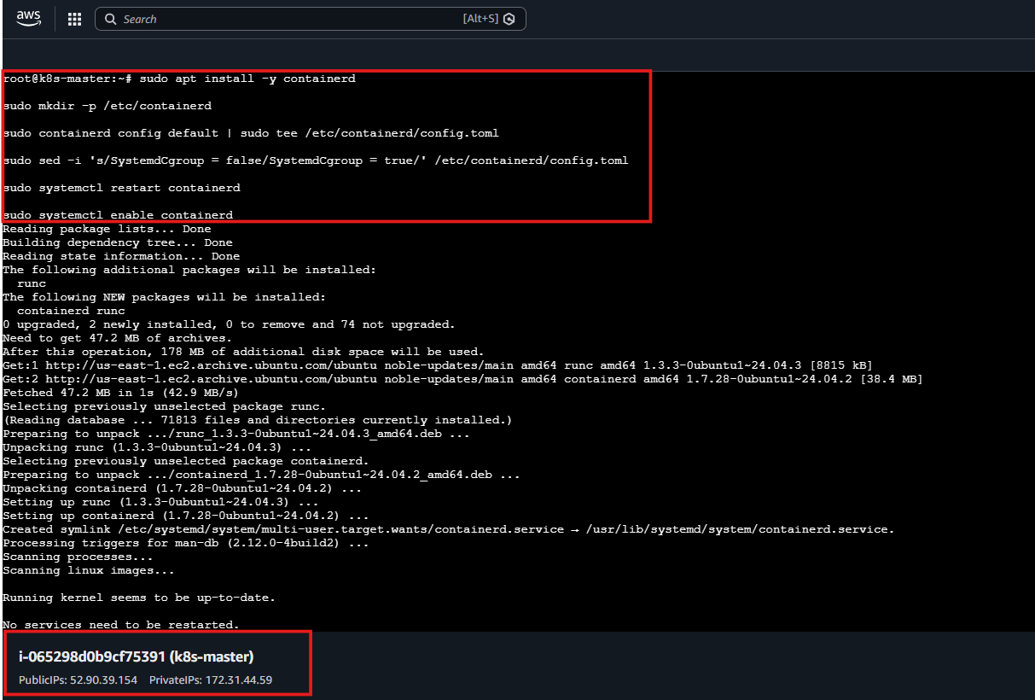

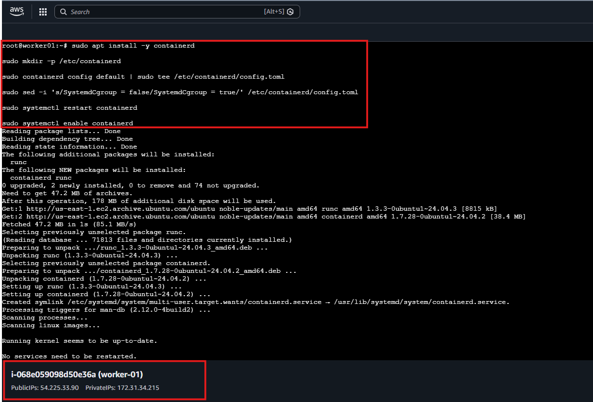

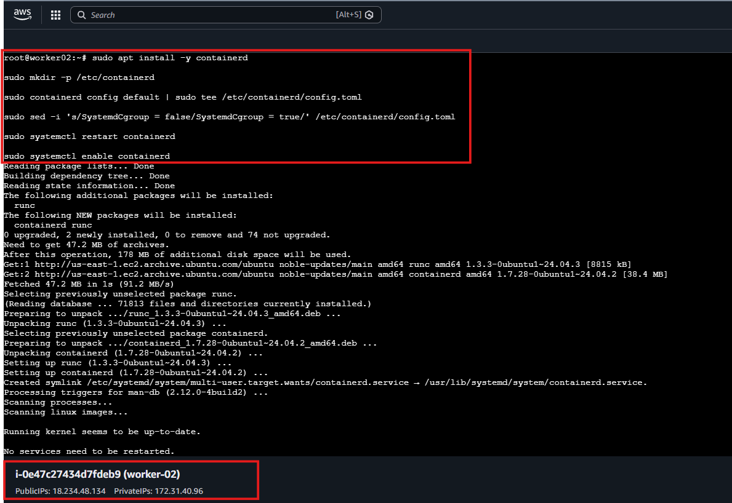

🔹 Step 7: Install Container Runtime on k8s-master only
Using:
sudo kubeadm config images pull
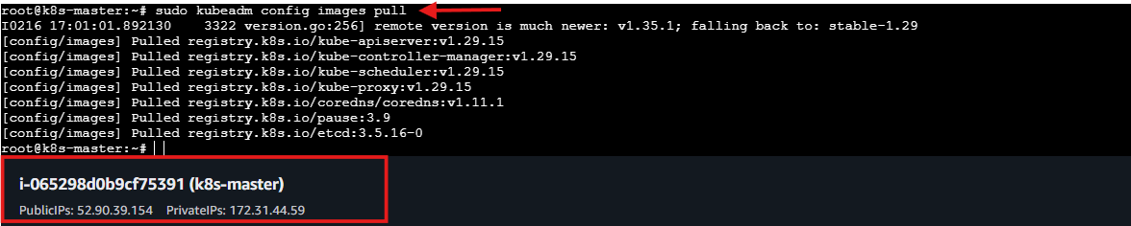
sudo kubeadm init --pod-network-cidr=10.10.0.0/16
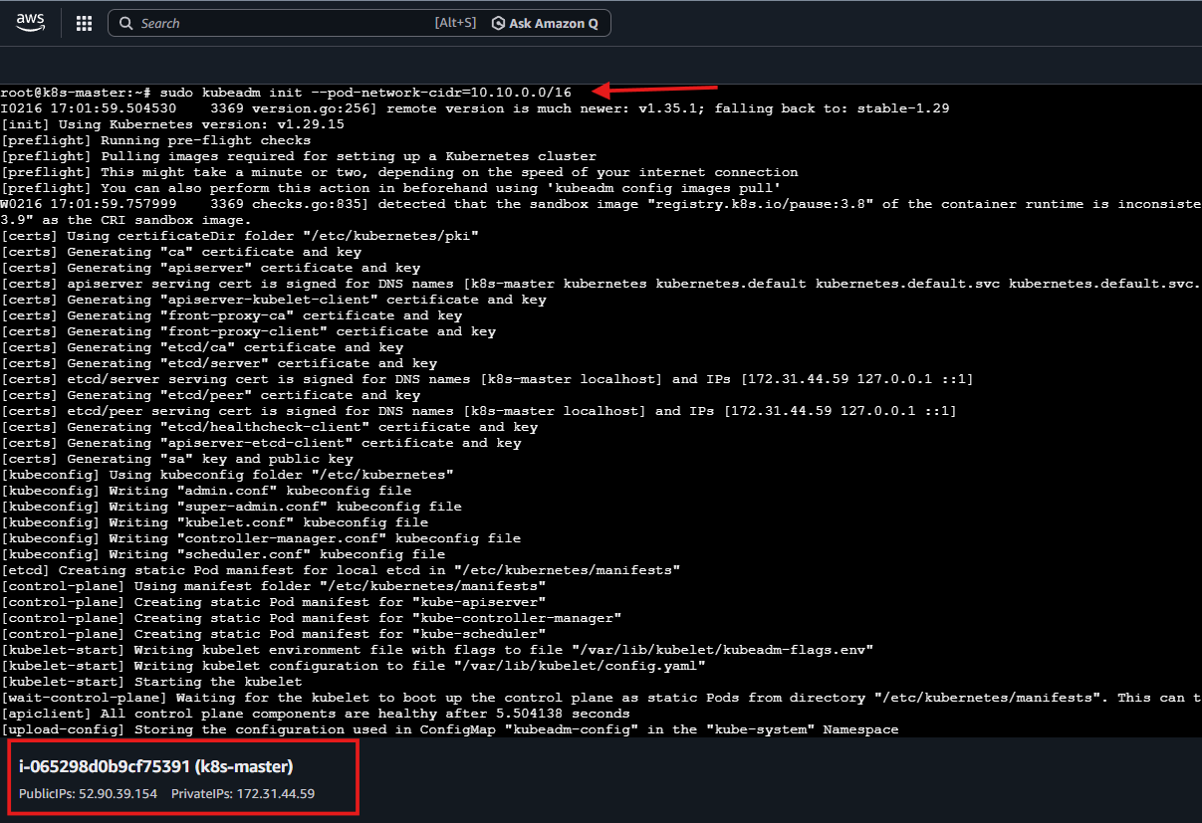
mkdir -p $HOME/.kube
sudo cp -i /etc/kubernetes/admin.conf $HOME/.kube/config
sudo chown $(id -u):$(id -g) $HOME/.kube/config
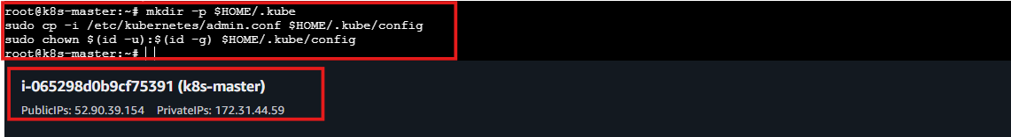
kubectl get nodes
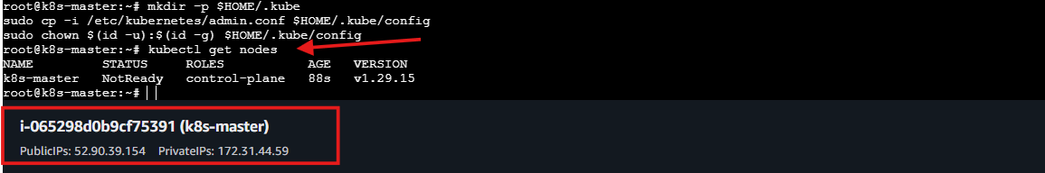
🔹 Step 8: Initialize Master Node
kubectl create -f https://raw.githubusercontent.com/projectcalico/calico/v3.26.1/manifests/tigera-operator.yaml
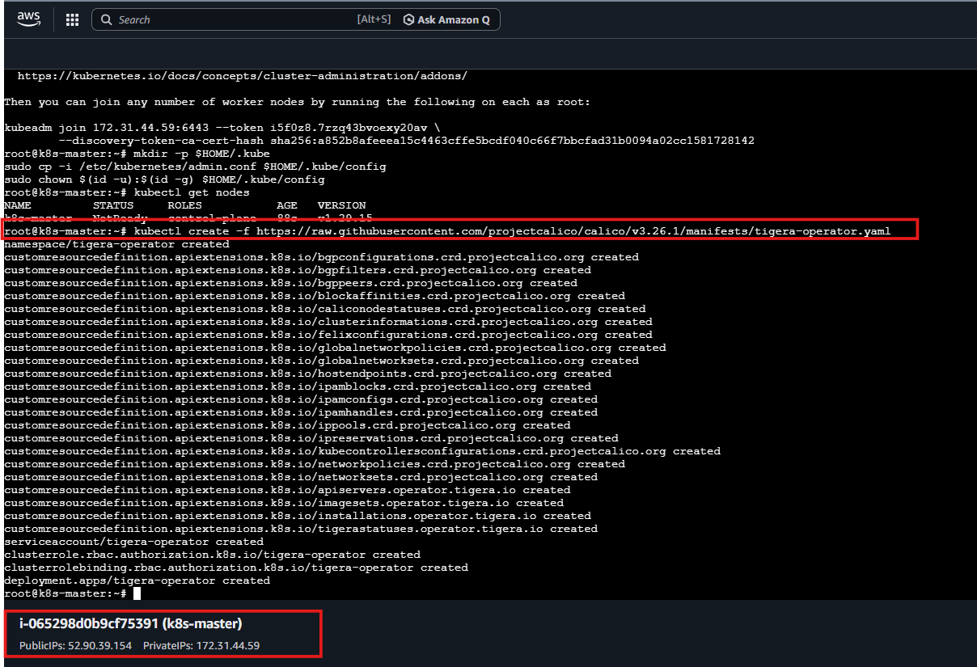
curl https://raw.githubusercontent.com/projectcalico/calico/v3.26.1/manifests/custom-resources.yaml -O
sed -i 's/192.168.0.0\/16/10.10.0.0\/16/g' custom-resources.yaml
kubectl create -f custom-resources.yaml
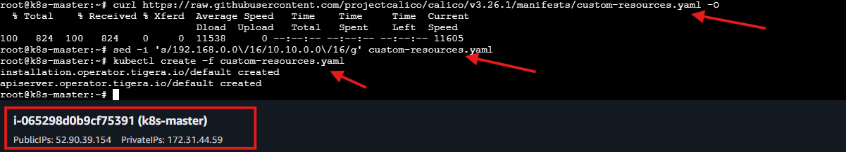
kubectl get nodes
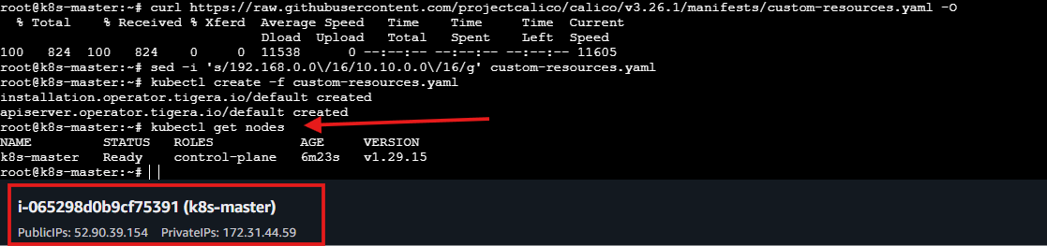

Step 9: Join Worker Nodes to create a token:
On Master:
kubeadm token create --print-join-command
Run the generated join command on:
- worker01
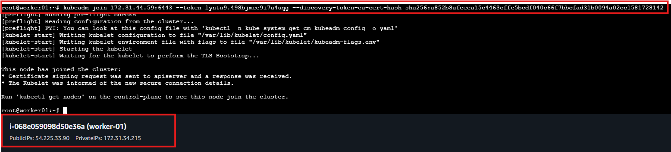
- worker02
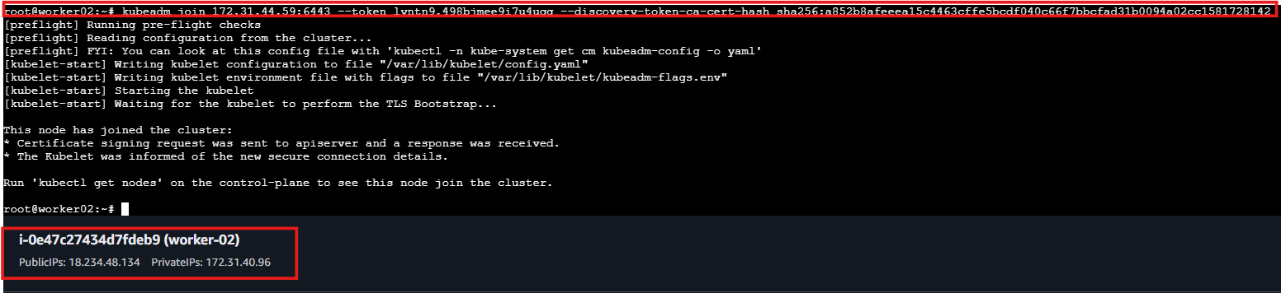
🔹 Step 11: Verify Cluster
kubectl get nodes
Output:
k8s-master Ready
worker01 Ready
worker02 Ready
Cluster successfully configured ✅
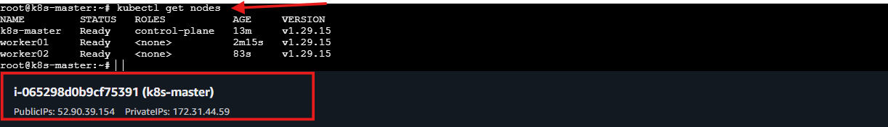

- Run one nginx pod.
Deploy:
kubectl create deployment nginx --image=nginx
Verify:
kubectl get pods
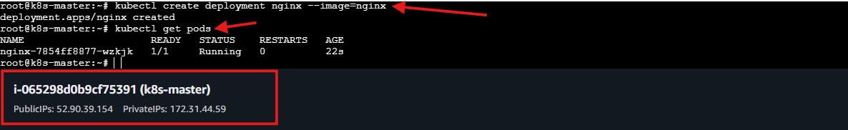
Expose service:
kubectl expose deployment nginx --type=NodePort --port=80
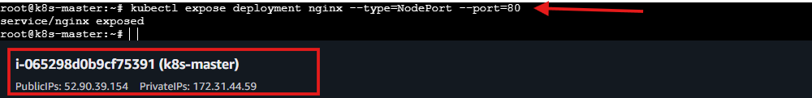
Get service details:
kubectl get svc
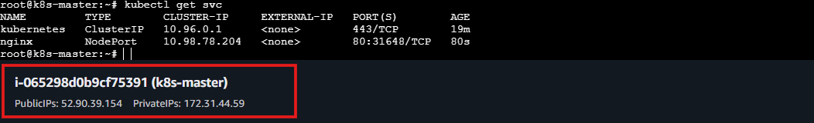
Access:
http://<node-ip>:<nodeport>
This runs:
NGINX inside Kubernetes.
From worker01: http://54.225.33.90:31648/
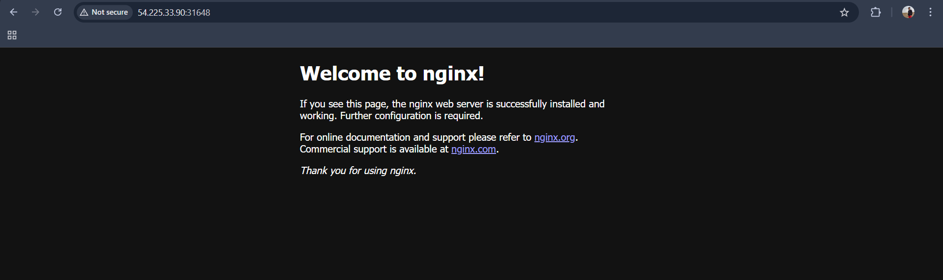
From worker02: http://18.234.48.134:31648/
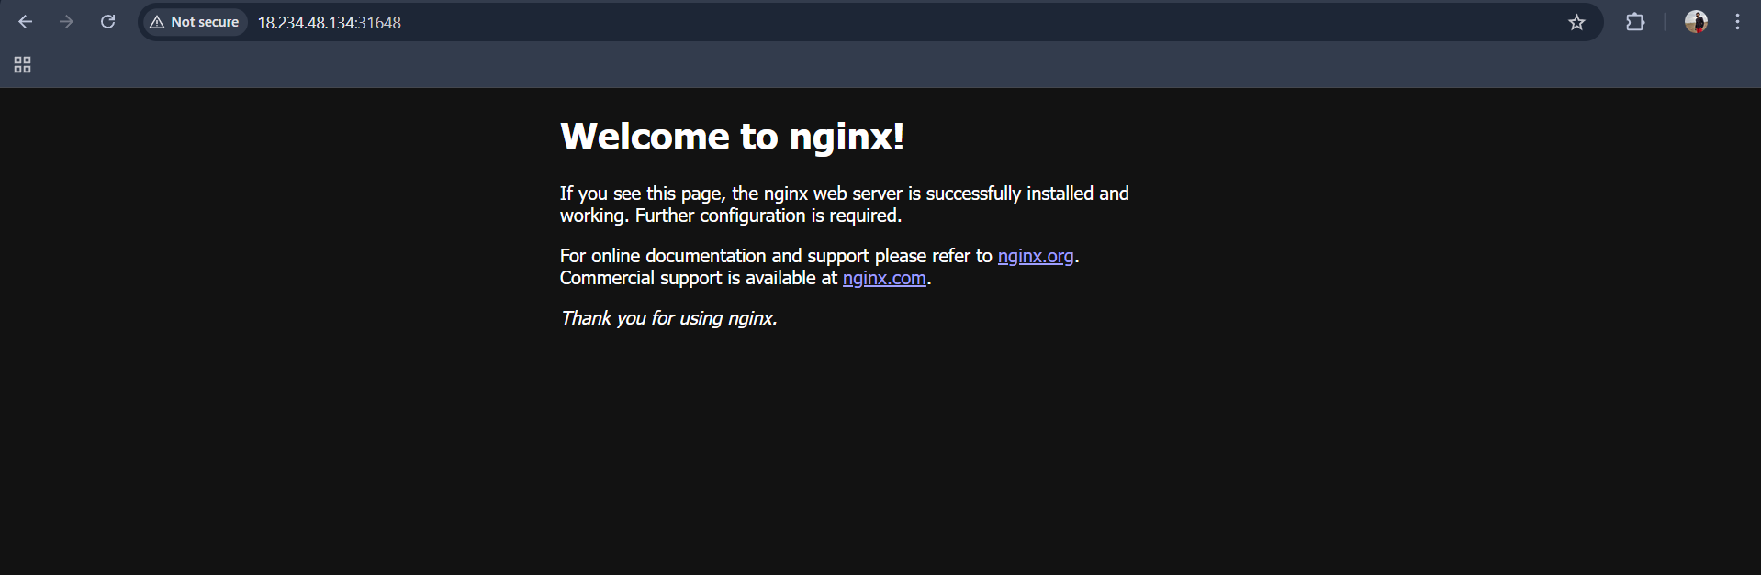

- Mugup Master and slave components on k8s.

🧠 Control Plane (Master Components)
The control plane manages the entire cluster. It makes global decisions (scheduling, scaling, responding to failures).
Main components:
1️⃣ kube-apiserver
- Entry point to the cluster
- Exposes the Kubernetes API
- All commands (kubectl, controllers, etc.) communicate through it
2️⃣ etcd
- Distributed key-value store
- Stores all cluster data (state, configuration, secrets)
3️⃣ kube-scheduler
- Assigns Pods to worker nodes
- Decides where containers should run based on resources and constraints
4️⃣ kube-controller-manager
- Runs controllers (background loops)
- Examples:
  - Node controller
  - ReplicaSet controller
  - Endpoint controller
5️⃣ cloud-controller-manager (optional)
- Integrates with cloud providers (AWS, Azure, GCP, etc.)

🖥 Worker Nodes (Slave Components)
Worker nodes run the actual application workloads.
Main components:
1️⃣ kubelet
- Agent running on each node
- Communicates with control plane
- Ensures containers are running in Pods
2️⃣ kube-proxy
- Handles networking
- Maintains network rules for services
- Enables service-to-pod communication
3️⃣ Container Runtime
- Runs containers
- Examples:
  - containerd
  - CRI-O
  - (Docker was supported earlier via dockershim)

📊 Simple Architecture Diagram (Conceptual)
Control Plane
-------------------
| API Server |
| Scheduler |
| Controllers |
| etcd |
-------------------
|
-------------------
| Worker Node 1 |
| kubelet |
| kube-proxy |
| Containers |
-------------------
| Worker Node 2 |
| kubelet |
| kube-proxy |
| Containers |
-------------------

🔄 How They Work Together
- You submit a deployment via kubectl.
- API Server stores the desired state in etcd.
- Scheduler assigns Pods to worker nodes.
- kubelet starts containers using the container runtime.
- Controllers continuously ensure the desired state matches the actual state.

